DERPARTMENT OF METHEMATICS AND ACTUARIAL SCIENCE
END OF FISRT SEMESTER EXAMINATION

COURSE NAME: COMPUTATIONAL SATISTICS
COURSE CODE: ASTA 607
STUDENT NAME: CHRISTABELL LUMOR
STUDENT ID: 22425652

- Description of mass data
Description
The crabs data frame has 200 rows and 8 columns, describing 5 morphological measurements on 50 crabs each of two colour forms and both sexes, of the species Leptograpsus variegatus collected at Fremantle, W. Australia.
Usage
crabs
Source
Campbell, N.A. and Mahon, R.J. (1974) A multivariate study of variation in two species of rock crab of genus Leptograpsus. Australian Journal of Zoology 22, 417–425.

B. Data Structure
> head(crabs)
sp sex index FL RW CL CW BD
1 B M 1 8.1 6.7 16.1 19.0 7.0
2 B M 2 8.8 7.7 18.1 20.8 7.4
3 B M 3 9.2 7.8 19.0 22.4 7.7
4 B M 4 9.6 7.9 20.1 23.1 8.2
5 B M 5 9.8 8.0 20.3 23.0 8.2
6 B M 6 10.8 9.0 23.0 26.5 9.8

>

C.Frequency table for spices and sex
> freq_tab_species_sex <- table(Species = crabs$sp, Sex = crabs$sex)
> freq_tab_species_sex
Sex
Species F M
B 50 50
O 50 50

D. Barplots for sex and species
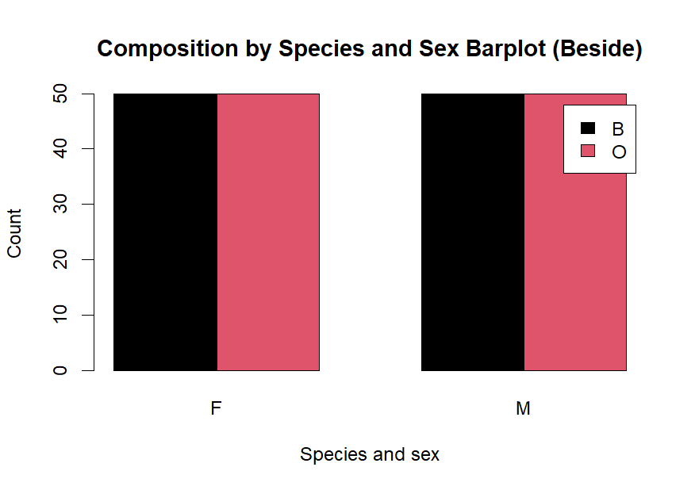

E.Comment on data set.
group_counts <- as.vector(tab_species_sex)
> min(group_counts)
[1] 50
> max(group_counts)
[1] 50
> min(group_counts) == max(group_counts)
[1] TRUE

Comment:from the above information and the equal frequency observered on the bar chat ,the data set is balanced across the groups

Question 2.
A.Side by side box plot.
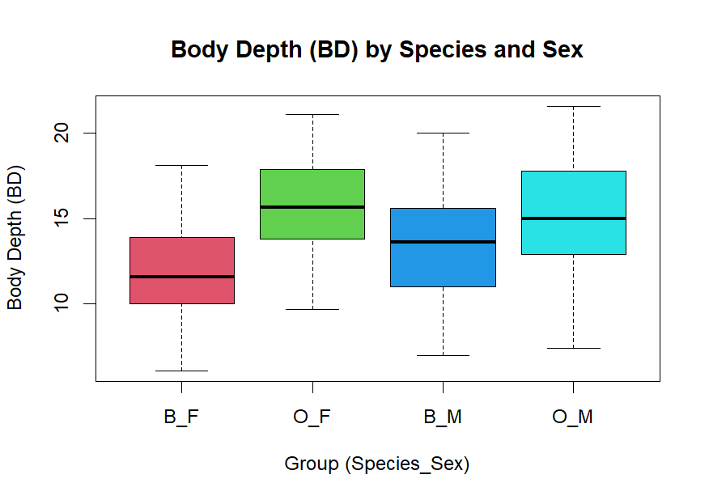

Question 3.
A.
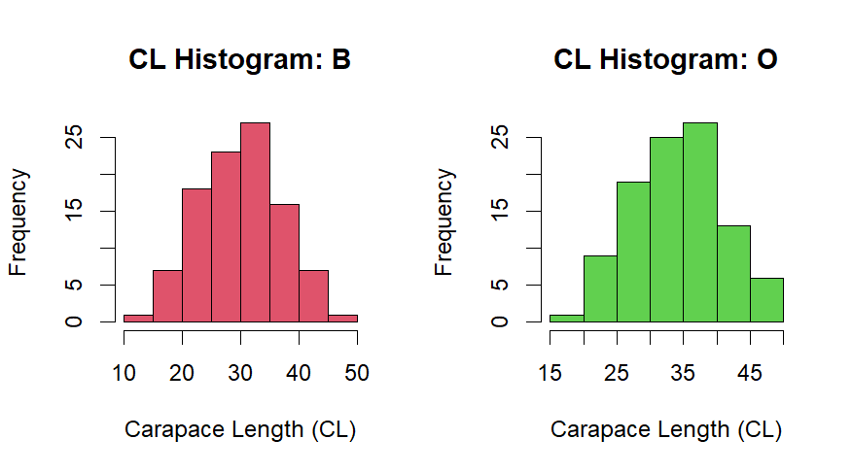

B.Skweness and Modality
# (b) Skewness and modality support (numeric summaries)
> by(crabs$CL, crabs$sp, summary)
crabs$sp: B
Min. 1st Qu. Median Mean 3rd Qu. Max.
14.70 24.85 30.10 30.06 34.60 47.10
---------------------------------------------------------
crabs$sp: O
Min. 1st Qu. Median Mean 3rd Qu. Max.
16.70 29.20 34.55 34.15 39.40 47.60

Comment:
- For both species, the mean and median are very close.
- This suggests the distributions are approximately symmetrical (little or no skewness).
- Species O has larger carapace lengths on average than Species B.
So, Species O crabs tend to be bigger than Species B crabs.
Question 4.
# (a) Mean of each morphological measurement (overall)
> overall_means <- colMeans(crabs[, c("FL","RW","CL","CW","BD")])
> overall_means
FL RW CL CW BD
15.5830 12.7385 32.1055 36.4145 14.0305

>

- Group Bar chat.
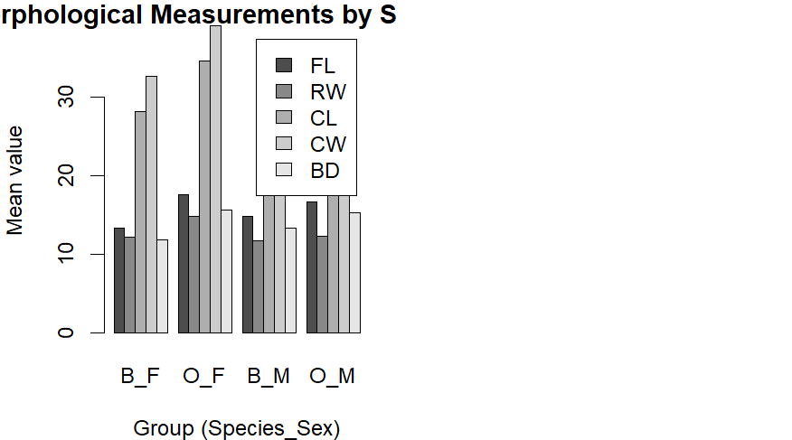

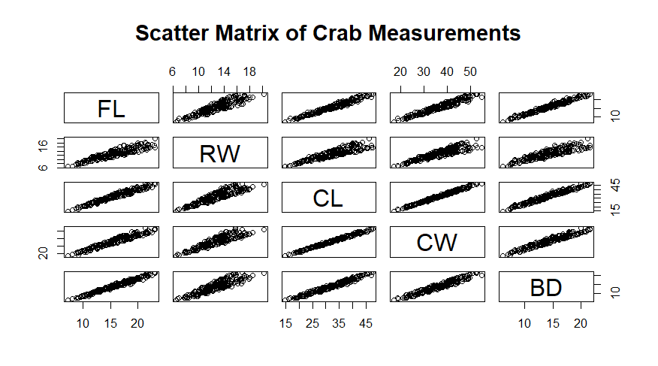

B.
# (b) Strength/nature of relationships: correlation matrix
> cor(crabs[, c("FL","RW","CL","CW","BD")])
FL RW CL CW BD
FL 1.0000000 0.9069876 0.9788418 0.9649558 0.9876272
RW 0.9069876 1.0000000 0.8927430 0.9004021 0.8892054
CL 0.9788418 0.8927430 1.0000000 0.9950225 0.9832038
CW 0.9649558 0.9004021 0.9950225 1.0000000 0.9678117
BD 0.9876272 0.8892054 0.9832038 0.9678117 1.0000000

(e) COMMENT

